Rotary Club of Kathmandu Mid-Town
Breakfast Chatter



24 November 2006 The Weekly Bulletin of Rotary Club of Kathmandu Mid-Town Bc # 21 of 2006-07

District : 3290 Web: www.rotarymidtown.org.np Club Id : 26776

NOVEMBER IS THE ROTARY FOUNDATION MONTH
The Rotary Foundation has two main streams of activity: programs and fundraising. The fundraising efforts fall into two main categories: The Annual Programs Fund, which supplies monies for the Educational and Humanitarian programs; and the Permanent Fund, which is Rotary's endowment — a fund whose principal is never spent and investment earnings are channeled into programs. The PolioPlus program is funded through a separate PolioPlus Fund.

Mr Ananda Banerjee, Vice President - Finance, Surya Nepal Pvt Ltd, while talking to the Club members at the Club's meeting on Friday morning 17 November, provided insights on e-Choupal, a market-led business model conceived and developed by ITC for delivering more value to its customers.
<--- Ananda answering to some of the questions raised by members during interaction after his brief presentation on "Unshackling the farmers by enabling information."
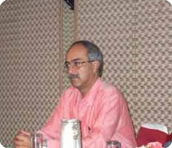

Weekly Meetings and Programs :
Date | Program/Speaker | Program/Topics of Presentation
24 Nov 2006 | No meeting
25 Nov 2006 | Charter Night | Charter Night Dinner meeting
1 Dec 2006 | Crystal Kaplan | Bhutanese refugees issues
8 Dec 2006 | Juergen Dahm | Helping poor and deprived children of Kathmandu
15 Dec 2006 | Club assembly | Club assembly

Friday, 24 November :
There will be no meeting on Friday morning, 24 November 2006. Instead, the Club will have dinner meeting on the following day, Saturday evening, 25 Nov 2006 to celebrate Club's anniversary.

Charter Night Dinner :
Rotary Club of Kathmandu Mid-Town will be celebrating their anniversary on Saturday, 25 Nov 2006.
Venue : Hotel Yak & Yeti
Time : 17:30 hrs
Registration : Rs 500 per person for the guests.
There will be a lot of fun. Don't miss it !

e-Choupal, a more efficient supply chain :
The e-Choupal model, conceived and developed by ITC's International Business Division, has been specifically designed to tackle the challenges posed by the unique features of Indian agriculture, characterised by fragmented farms, weak infrastructure and the involvement of numerous intermediaries, among others.
‘e-Choupal’ also unshackles the potential of Indian farmer who has been trapped in a vicious cycle of low risk taking ability > low investment > low productivity > weak market orientation > low value addition > low margin > low risk taking ability. This made him and Indian agribusiness sector globally uncompetitive, despite rich & abundant natural resources.
Such a market-led business model can enhance the competitiveness of Indian agriculture and trigger a virtuous cycle of higher productivity, higher incomes, enlarged capacity for farmer risk management, larger investments and higher quality and productivity.
Further, a growth in rural incomes will also unleash the latent demand for industrial goods so necessary for the continued growth of the Indian economy. This will create another virtuous cycle propelling the economy into a higher growth trajectory.
With a judicious blend of click & mortar capabilities, village internet kiosks managed by farmers – called sanchalaks – themselves, enable the agricultural community access ready information in their local language on the weather & market prices, disseminate knowledge on scientific farm practices & risk management, facilitate the sale of farm inputs (now with embedded knowledge) and purchase farm produce from the farmers’ doorsteps (decision making is now information-based).
Real-time information and customised knowledge provided by ‘e-Choupal’ enhance the ability of farmers to take decisions and align their farm output with market demand and secure quality & productivity. The aggregation of the demand for farm inputs from individual farmers gives them access to high quality inputs from established and reputed manufacturers at fair prices. As a direct marketing channel, virtually linked to the ‘mandi’ system for price discovery, ‘e-Choupal’ eliminates wasteful intermediation and multiple handling. Thereby it significantly reduces transaction costs.
While the farmers benefit through enhanced farm productivity and higher farm gate prices, ITC benefits from the lower net cost of procurement (despite offering better prices to the farmer) having eliminated costs in the supply chain that do not add value.
Source : www.echoupal.com

Inauguration of Nepal Glaucoma Eye Clinic and Handing Over of Ambulance on 18 Nov 2006 :

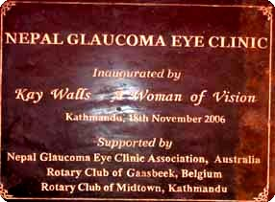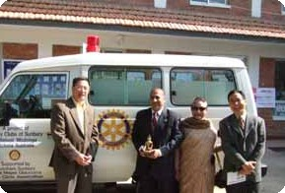
a) NGEC's Inscription on the wall of the building. NGEC was inaugurated at
a special ceremony at Tilganga Eye Centre on Saturday, 18 Nov 2006.
b) President CK Golchha, PP Ambica Shrestha, PP Mani D Joshi and PP William Ma posed for
a photo after handing over Ambulance to Nepal Glaucoma Eye Clinic same day.

On Lighter Side : Click at the figure ⇩


Rotarians know the value of a good investment. That is why every year, Rotarians give to the Foundation. We know that our money will be used well and wisely by our fellow Rotarians and that together we can do so much more than we could ever do alone. That is why I ask all of you to Lead the Way in your clubs with a gift to the Foundation - this year and every year.
RI President William B. Boyd

24 November 2006 The Weekly Bulletin of Rotary Club of Kathmandu Mid-Town Bc # 21 of 2006-07

Editor: RR Shrestha, Club Service Director email: rryes@wlink.com.np

